When You Can’t Draw a Trendline, Trading Becomes Gambling
Intro Image
When a market structure does not allow a valid trendline to be drawn, trading in such conditions is essentially no different from gambling.
In today’s session, the market repeatedly presented areas that looked like opportunities, but where the structure was not actually valid.
This review is not about teaching you how to enter trades. It is about teaching you when to stay out.

1. BTC
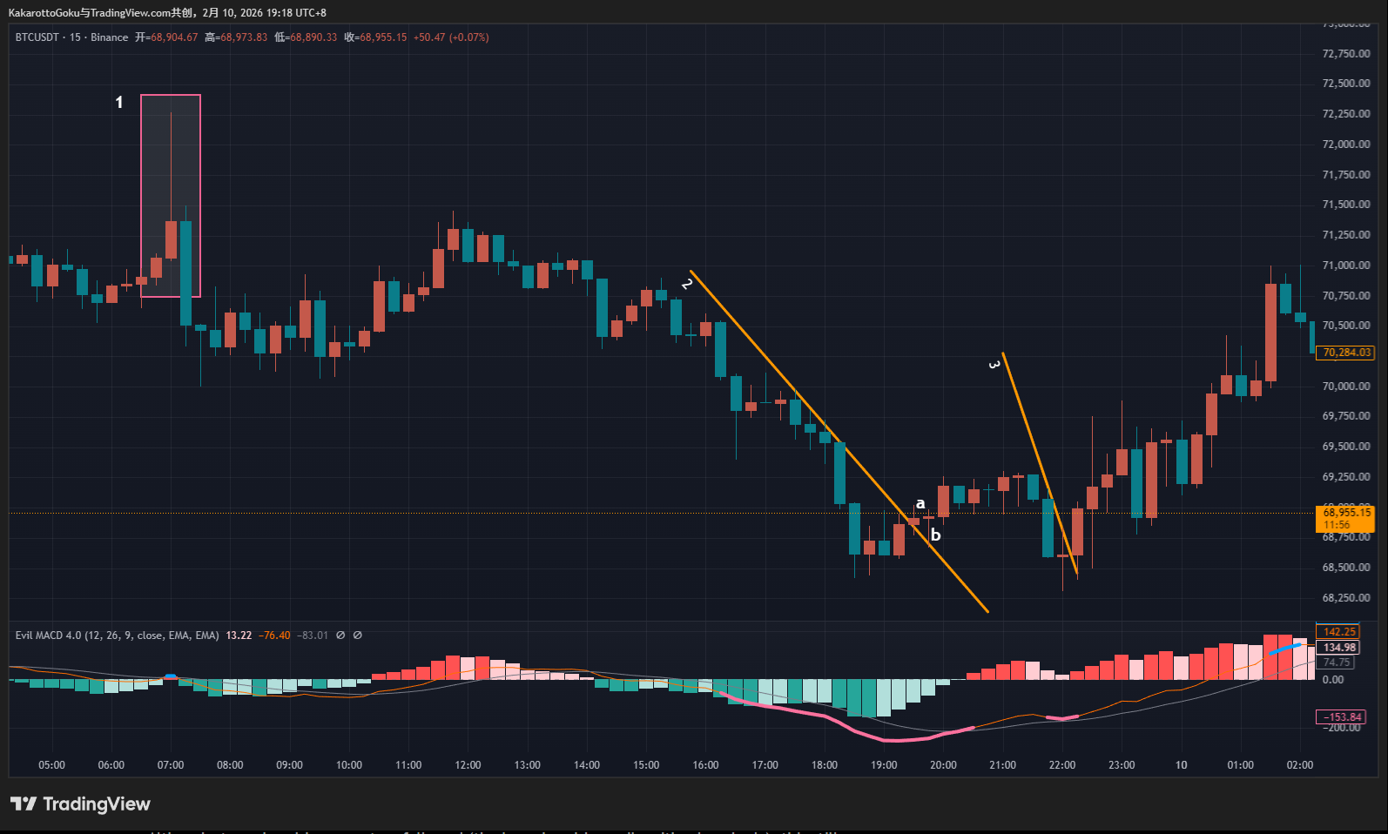
BTC Chart
First, we see the initial blue top warning signal, marking Area 1 (highlighted by the pink box). This is a zone where no valid trendline can be drawn.
Pay close attention to the large bullish candle with an extremely long upper wick. Even if a trendline could be forced onto this structure, such an extreme price move introduces randomness and instability into the market.
Although strong bearish momentum followed (the large bearish candle with a long body), this still does not justify a short entry. This is a high-risk consolidation zone, and staying out is the best decision.
Later, a long red warning sequence appeared, indicating a potential bottom. Price then developed Trendline 2, which was broken at point a.
First, Trendline 2 itself is not high quality. Before point a, price formed a triangular structure that clearly deviated from the trendline. This is a 15-minute chart — a cleaner trendline may exist on a 5-minute or lower timeframe.
The key principle here is simple: trade only the timeframe you specialize in. If a valid trend cannot be identified on your chosen timeframe, do not rely on lower timeframes to justify an entry.
Second, candle a has a small body with upper and lower wicks, very close to a doji. Candle b has an even smaller body with a long lower wick. Although price broke above Trendline 2, there is no clear bullish momentum.
Therefore, neither a nor b qualifies as an optimal reversal entry.
Later, another thick pink line appeared, indicating a potential bottom, followed by a doji and an upward break. However, the line marked 3 does not form a valid trendline.
This line has not been properly validated by the market. This is a very common situation: forcing a setup simply because we want to trade.
Lowering entry standards in order to participate — trading for the sake of trading — is the root cause of many losses.
The correct approach is to rely strictly on objective conditions. When conditions are not met, the correct action is to pass.
Remaining flat and reducing stop-loss exposure is a core trading principle.
As before, while a valid trendline may exist on a lower timeframe, none is confirmed on the current timeframe. If you want to trade, you must shift to a lower timeframe — the logic remains the same. Only follow entries that fully align with your trading system.

2. ETH
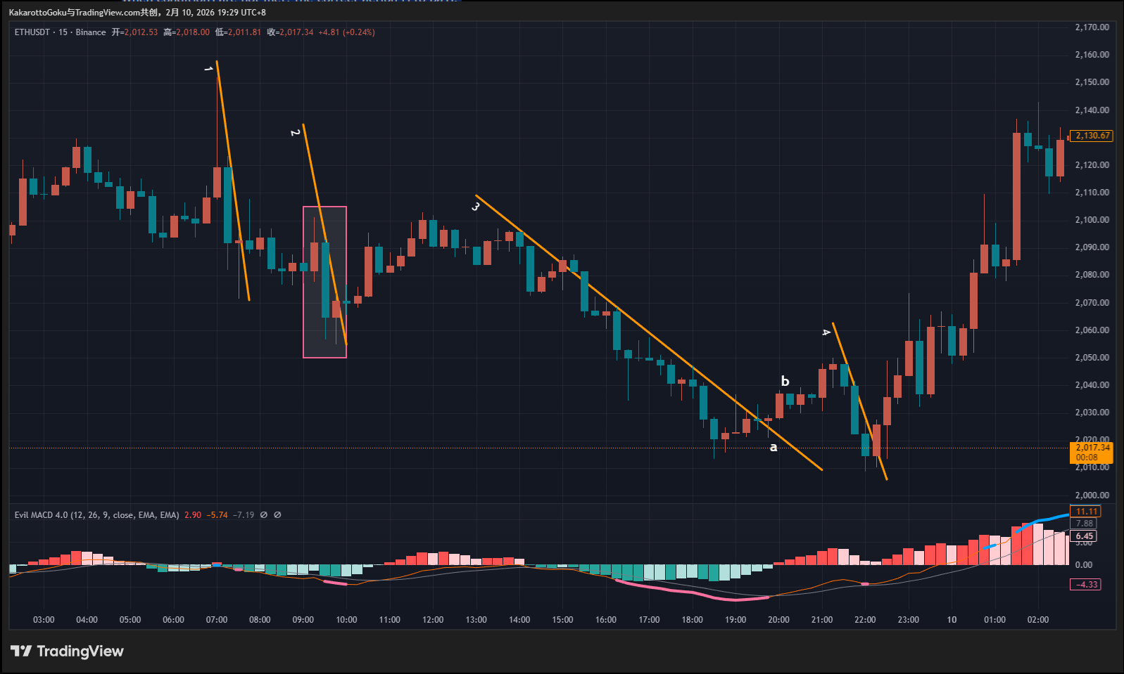
ETH Chart
At the beginning, we again see low-quality trend structures.
At Trendline 1, although a trendline can technically be drawn, both the first and third candles have very long wicks. This indicates extreme behavior from both buyers and sellers.
Even with pink or blue warning signals, this type of market should be avoided.
Later, a pink bottom warning appeared. However, in Area 2, no valid trendline can be drawn. Line 2 simply connects two arbitrary points and does not represent a true trend.
In this case, trendline theory cannot be applied.
Trendlines 3 and 4, however, are very different.
For Trendline 3, a pink bottom warning appeared and price broke upward at point a. Candle a still has a small body and weak bullish momentum.
By waiting briefly, a strong bullish candle b appeared. This represents a clearer and more reliable bullish market consensus.
This is a valid system-based entry. Whether profits were managed with a trailing stop or stopped out due to delayed stop movement, this trade falls entirely within the rules of the trading system.
Later, Trendline 4 formed, accompanied by another pink bottom warning. Price broke upward with a strong bullish candle, once again forming a high-probability bullish consensus.
Following this setup provided significant upside potential.

3. Gold
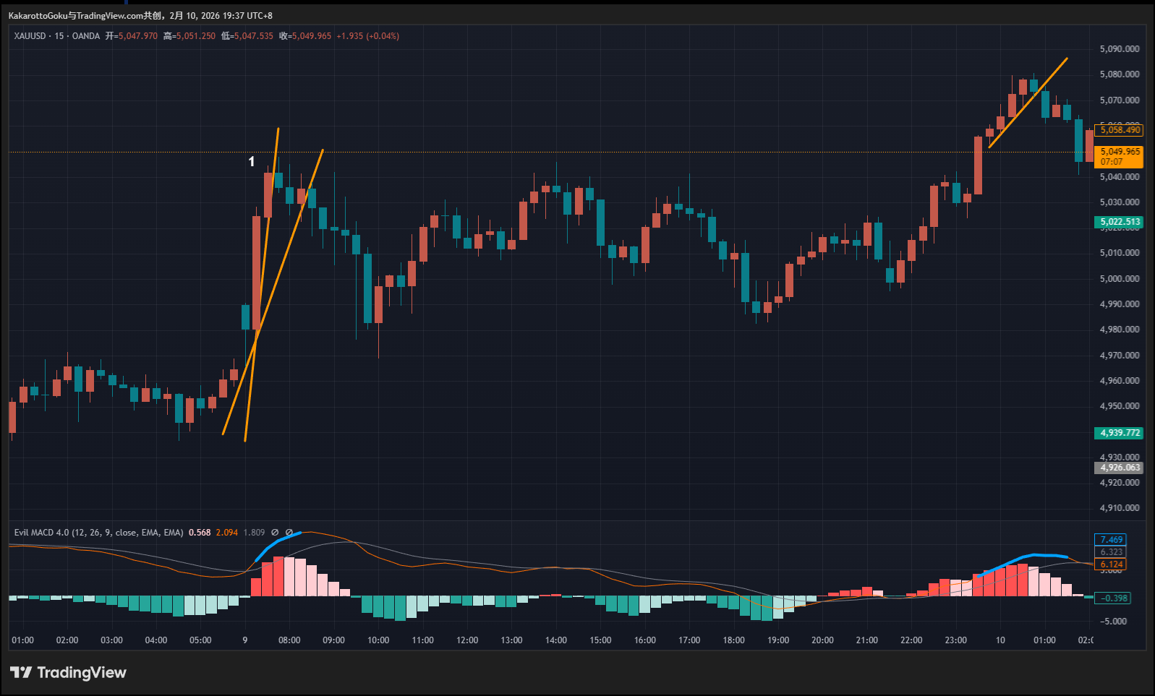
Gold Chart
Today, only one blue top warning signal appeared.
In Area 1, the large bullish candle reflects strong bullish momentum. However, buying pressure suddenly disappeared, followed by several candles with long wicks — a clear sign of intense two-sided conflict.
More importantly, no valid trendline can be drawn.
The two yellow lines shown on the chart are not standard trendlines. The inability to form a proper trendline is primarily caused by the large bullish candle.
When markets experience such sudden price expansions, directional judgment becomes extremely difficult. Entering trades under these conditions is no different from gambling.
Protect your capital. Stay away from gambling behavior.

Summary
Today’s market clearly demonstrates the difference between entering at standard, high-quality setups and entering at forced or substandard locations.
When trades are taken from weak structures or barely valid trendlines, random market noise often triggers stop losses.
When entries are taken in alignment with true market consensus, losses are still possible — but the probability of success increases significantly.
Most importantly, the risk-to-reward profile becomes decisively favorable.

